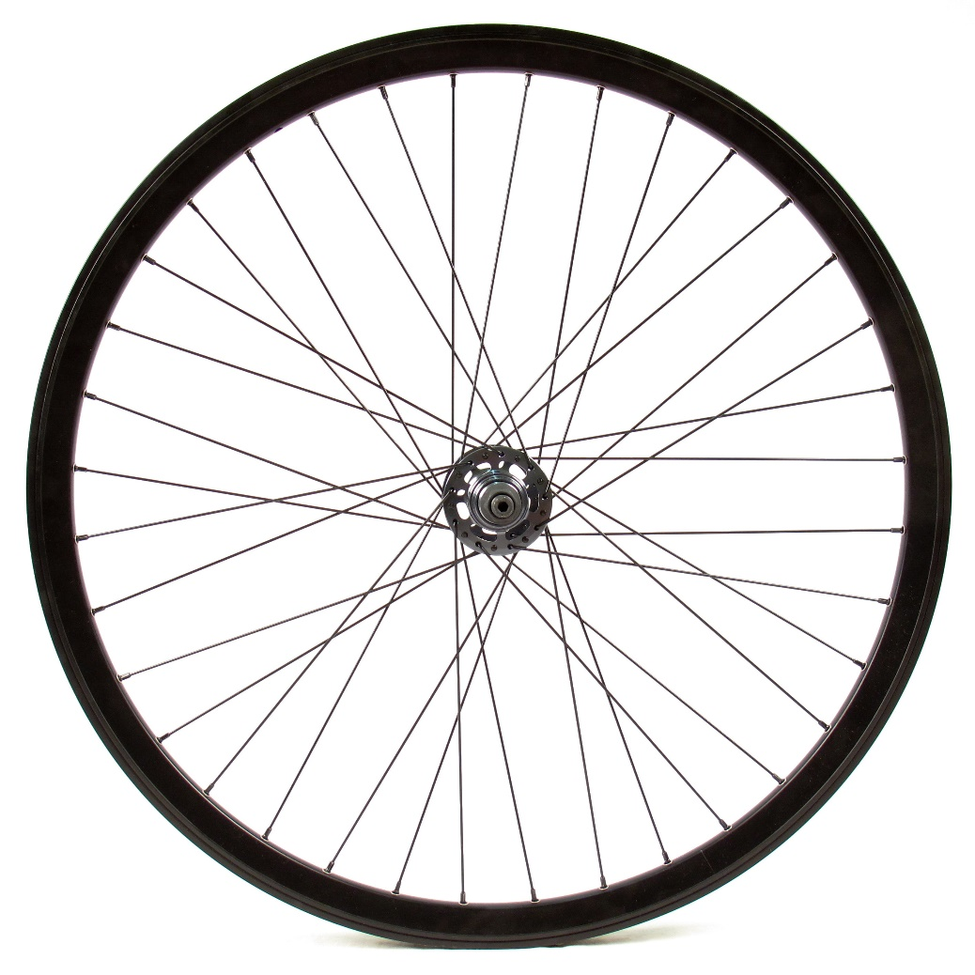

<http://clipground.com/spoke-wheel-clipart.html>

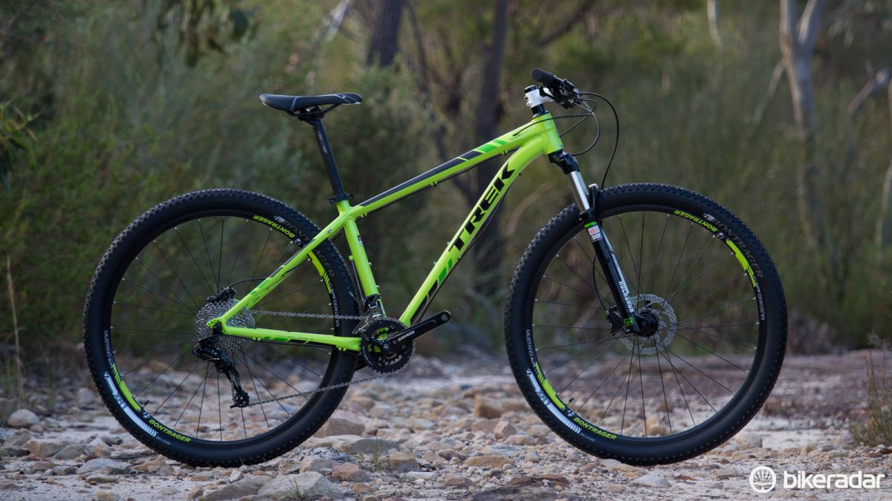

<https://www.bikeradar.com/mtb/gear/category/bikes/mountain-bikes/29er/product/review-trek-x-caliber-8-49060/>

Trek

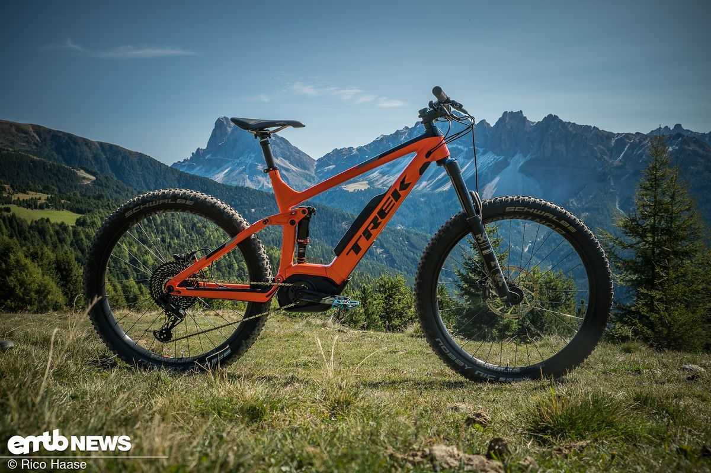

<https://www.emtb-news.de/news/en/test-trek-powerfly-9-lt/>

Trek

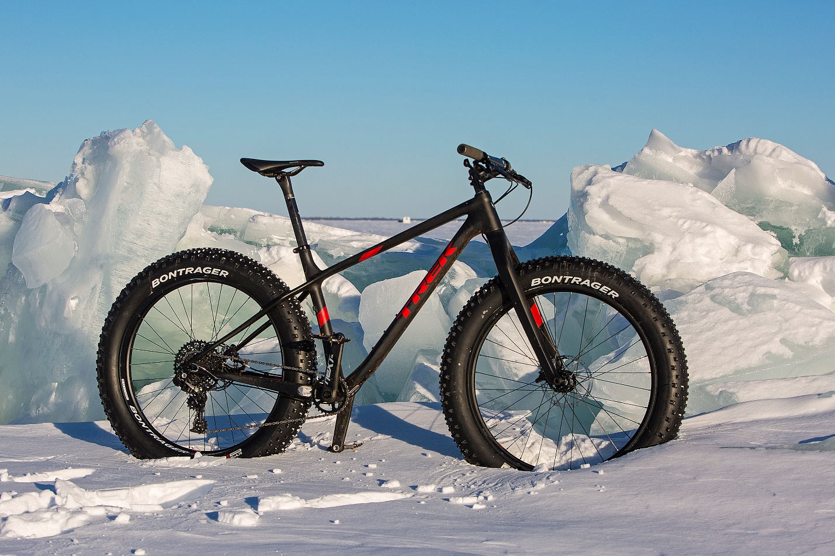

<https://fat-bike.com/2016/03/trek-farley-9-8-the-winter-review/>

Trek

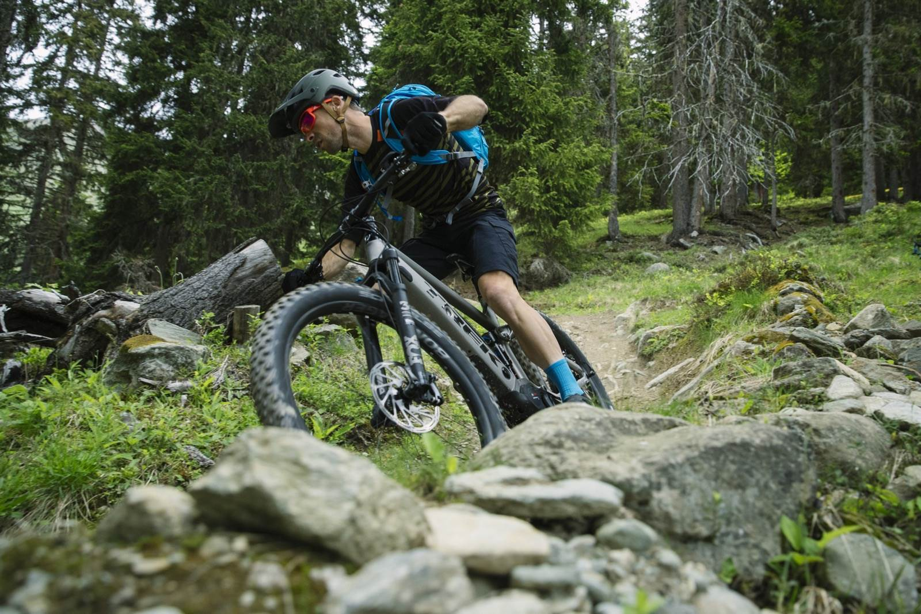

<https://www.ambmag.com.au/gallery/treks-new-powerfly-headlines-the-2018-trail-range-466976>

Trek

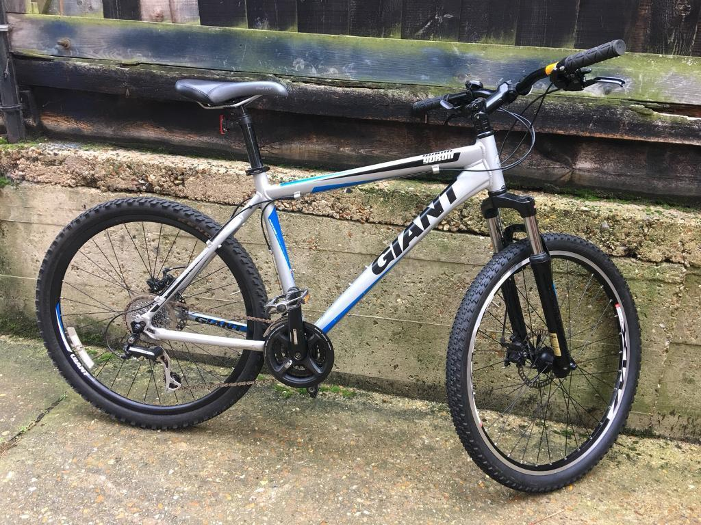

<https://www.gumtree.com/p/bicycles/giant-mountain-bikes-disc-brakes-/1281895070>

Giant

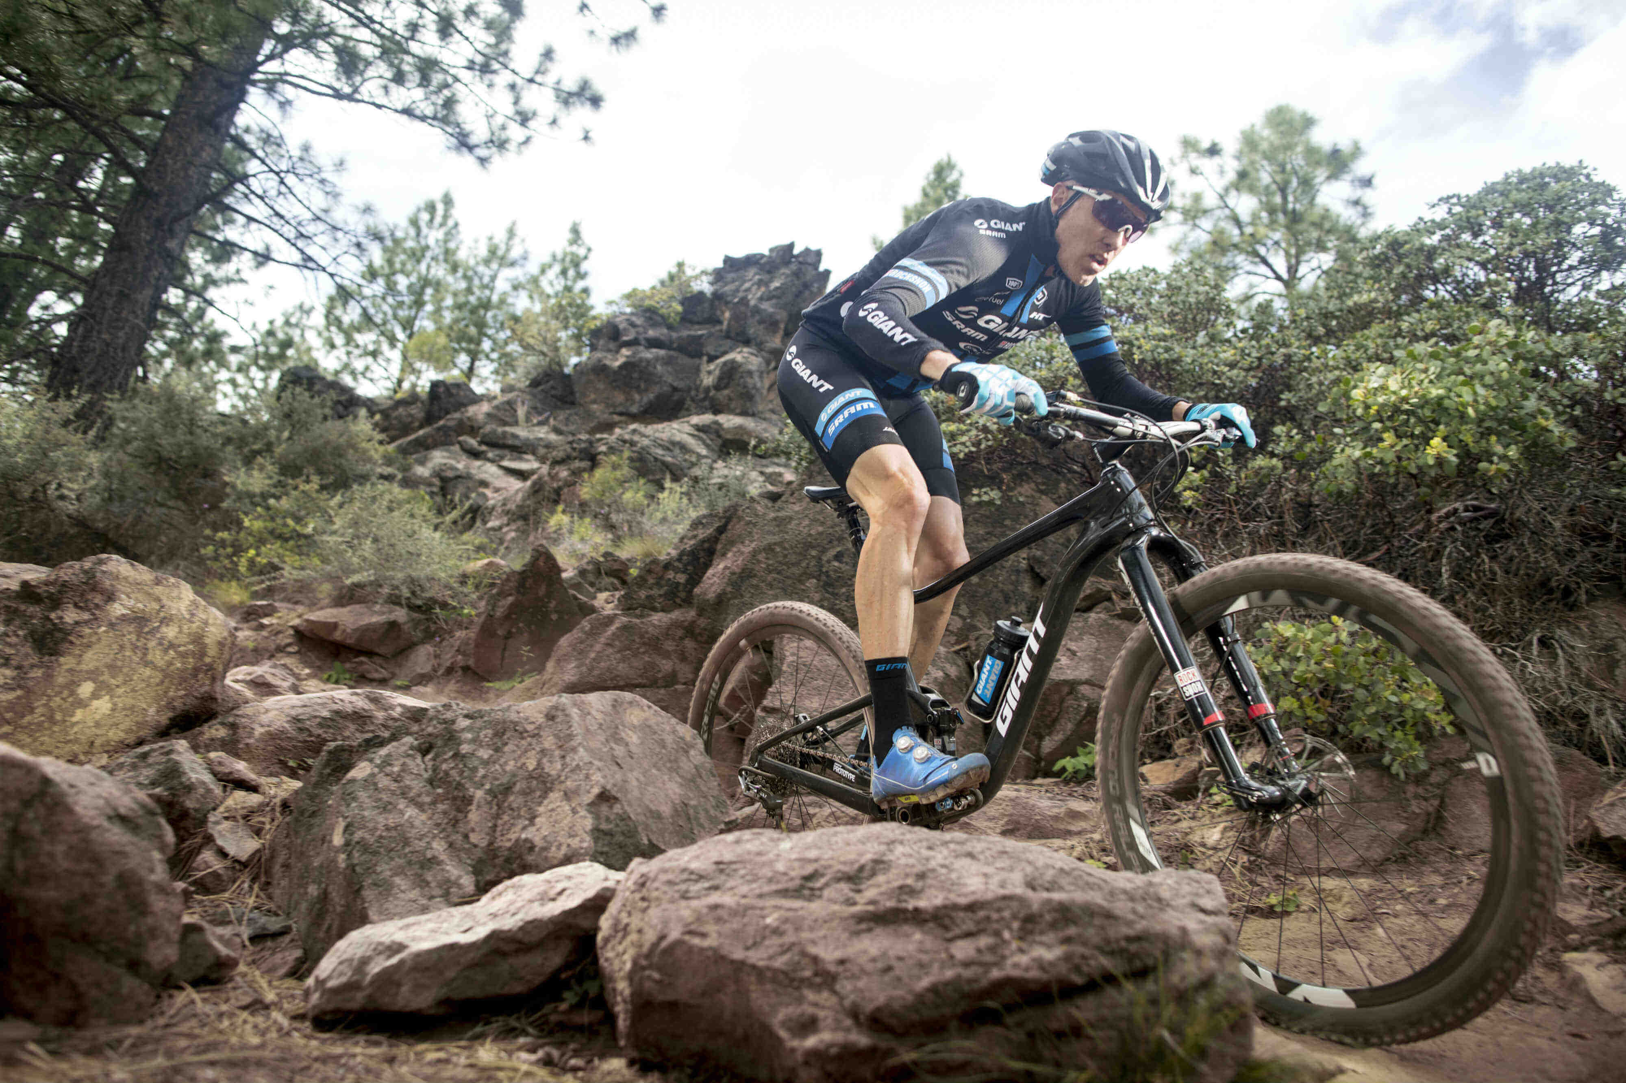

<https://www.mantel.com/blog/en/giant-mountain-bikes-boost-2017/>

Giant

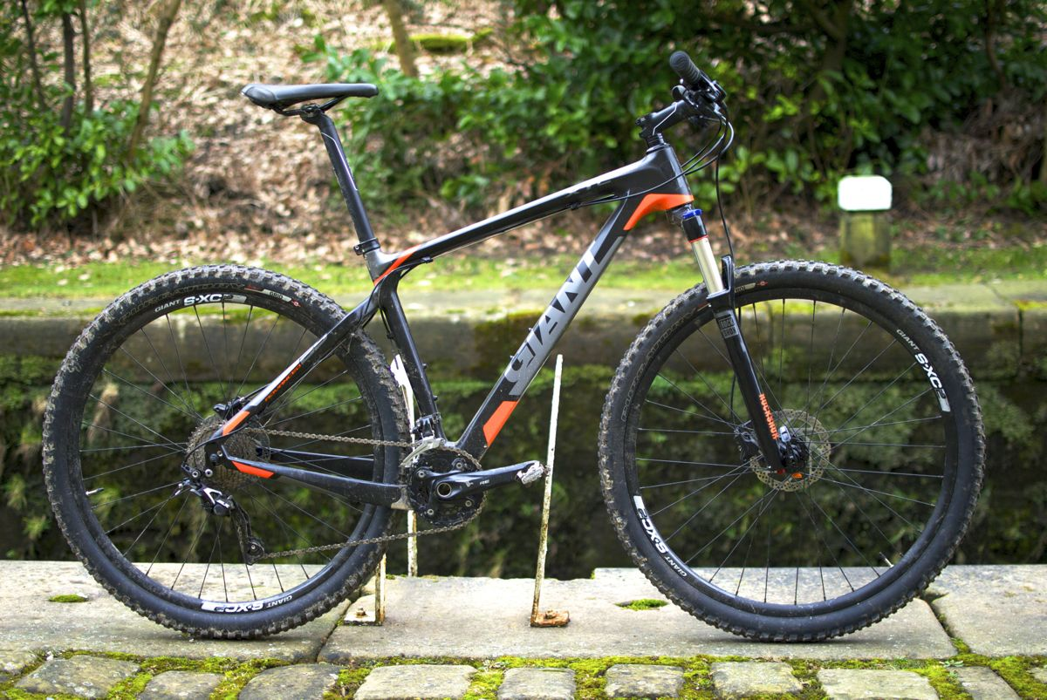

<https://singletrackworld.com/2015/02/giant-xtc-advanced-29er-2/>

Giant

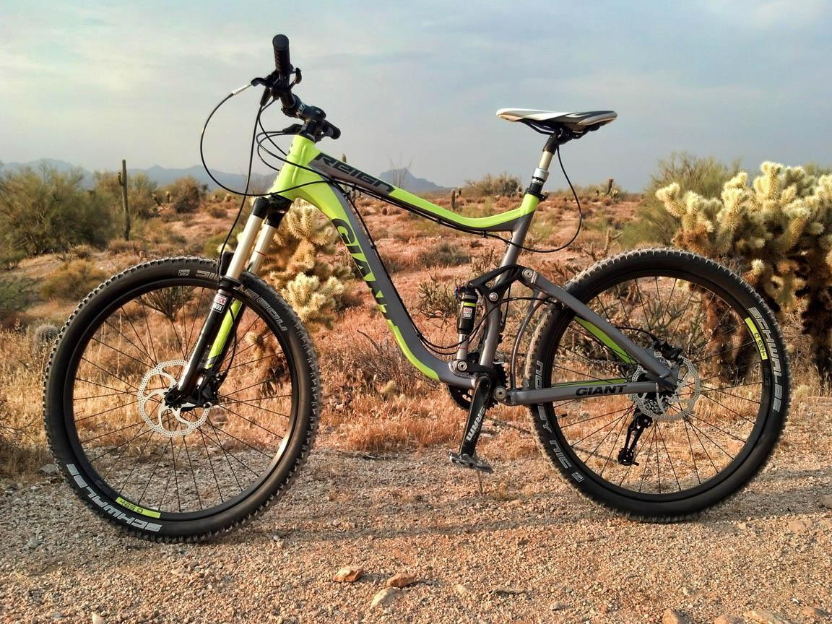

<https://www.singletracks.com/bike-reviews/All-Mountain-bikes/Giant-Reign_7414>

Giant

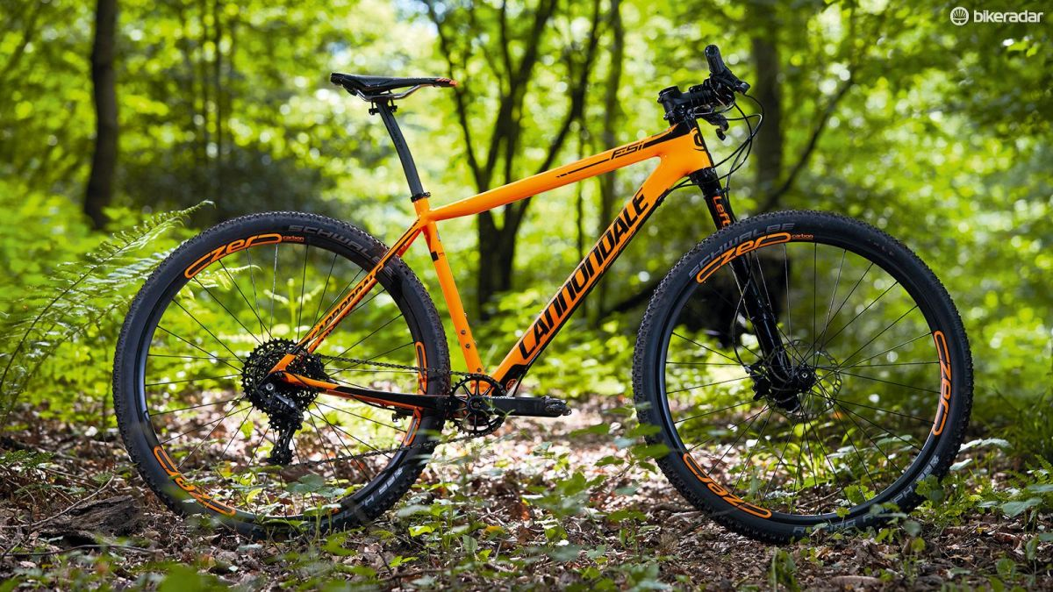

<https://www.bikeradar.com/mtb/gear/category/bikes/mountain-bikes/hardtail/product/cannondale-fsi-carbon-2-review-50595/>

Cannondale

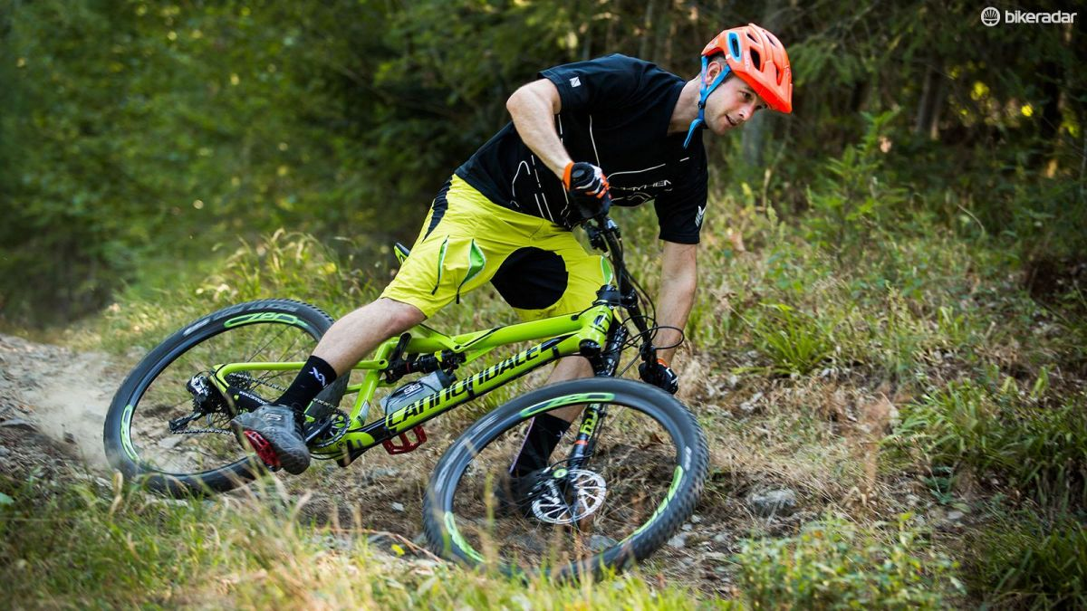

<https://www.bikeradar.com/mtb/gear/category/bikes/mountain-bikes/full-suspension/product/review-cannondale-habit-carbon-1-2016-49713/>

Cannondale

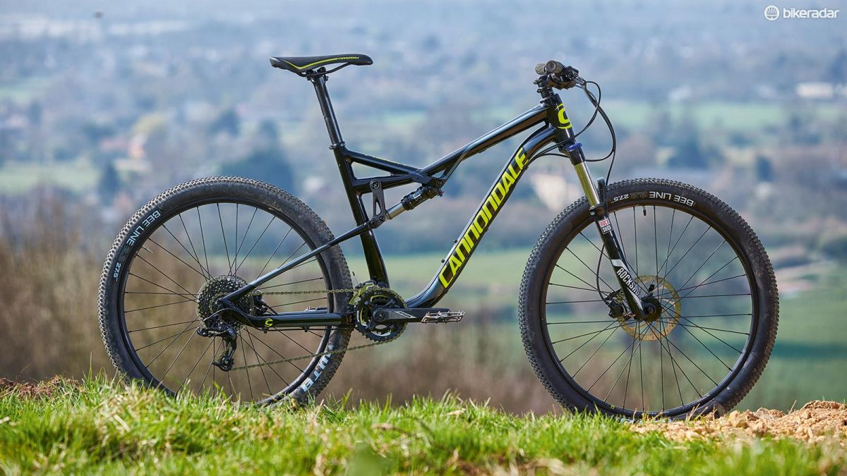

<https://www.bikeradar.com/mtb/gear/category/bikes/mountain-bikes/full-suspension/product/cannondale-habit-6-review-51494/>

Cannondale

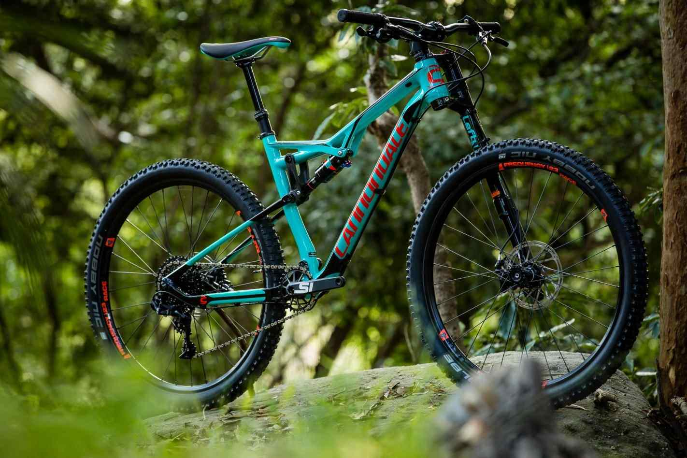

<https://cubangbak.info/mountain-bike/cannondale-mountain-bikes.html>

Cannondale

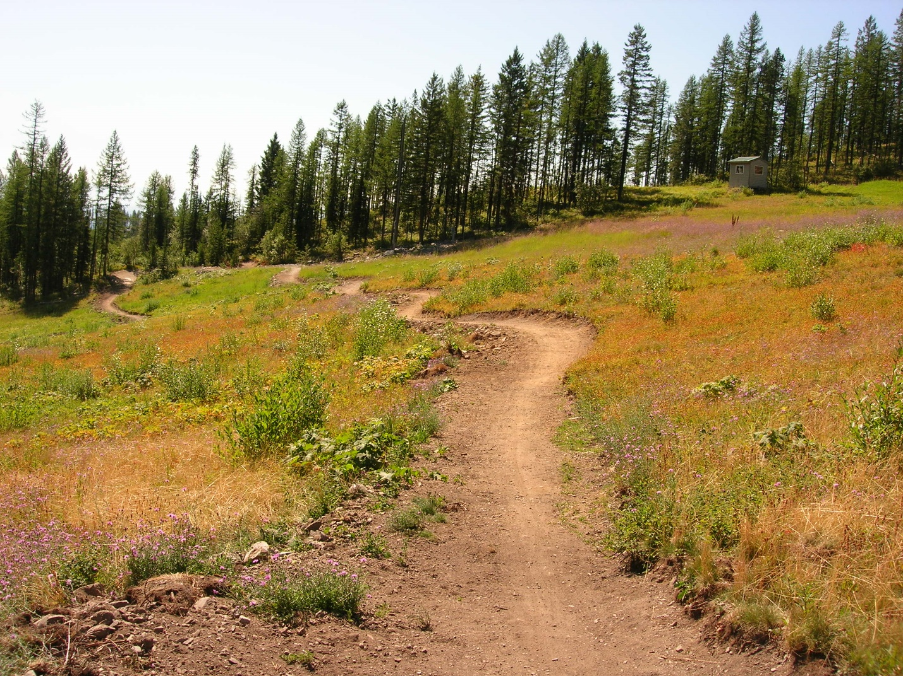

<https://www.fs.usda.gov/activity/flathead/recreation/bicycling/?recid=66162&actid=24>

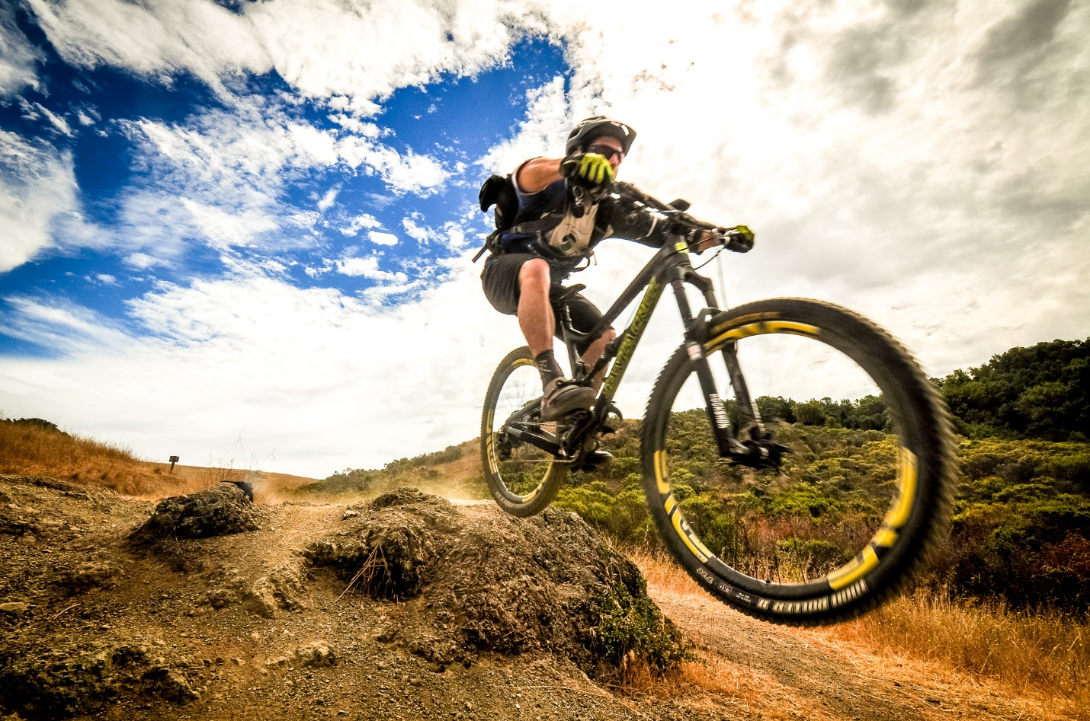

<https://mountainbikesf.com/>

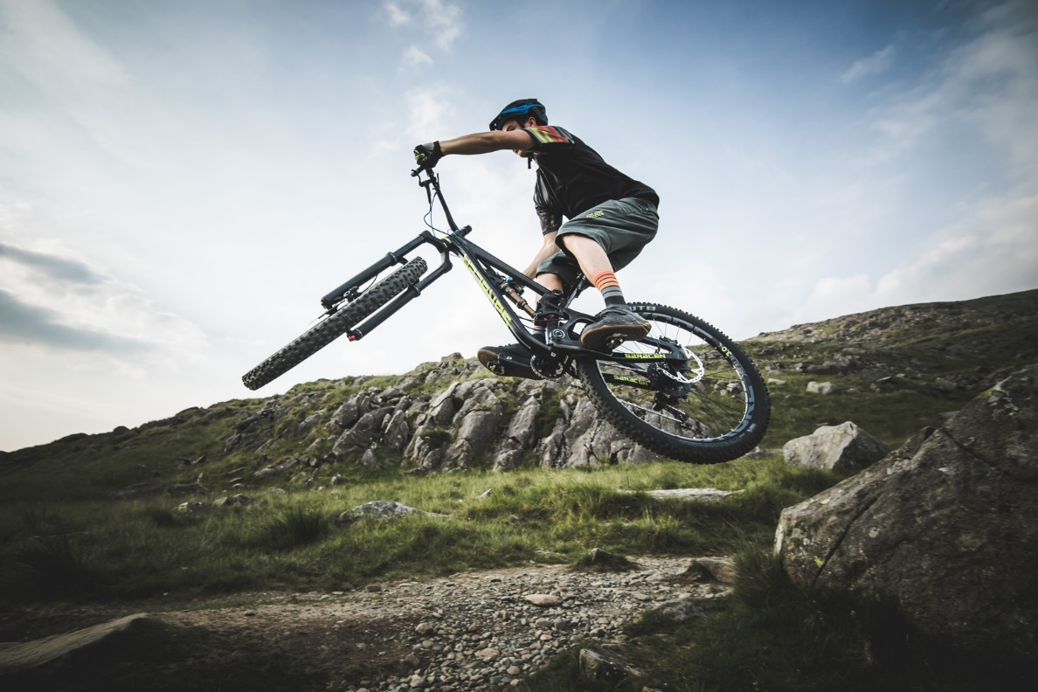

<https://www.saracen.co.uk/bikes/mountain>

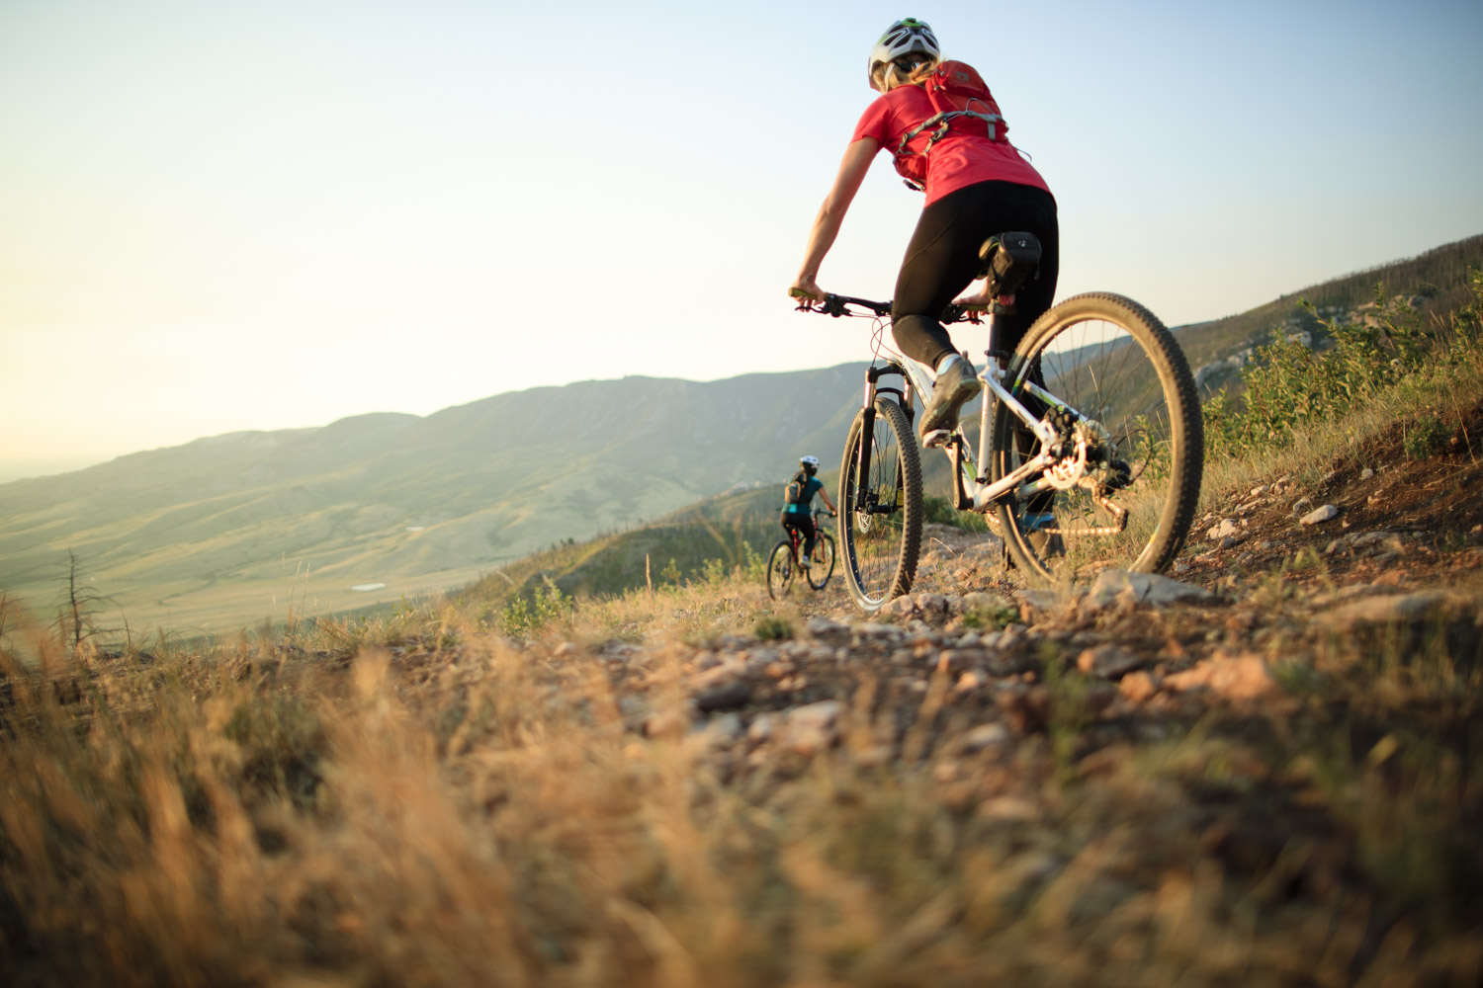

<https://www.travelwyoming.com/things-to-do/mountain-biking>

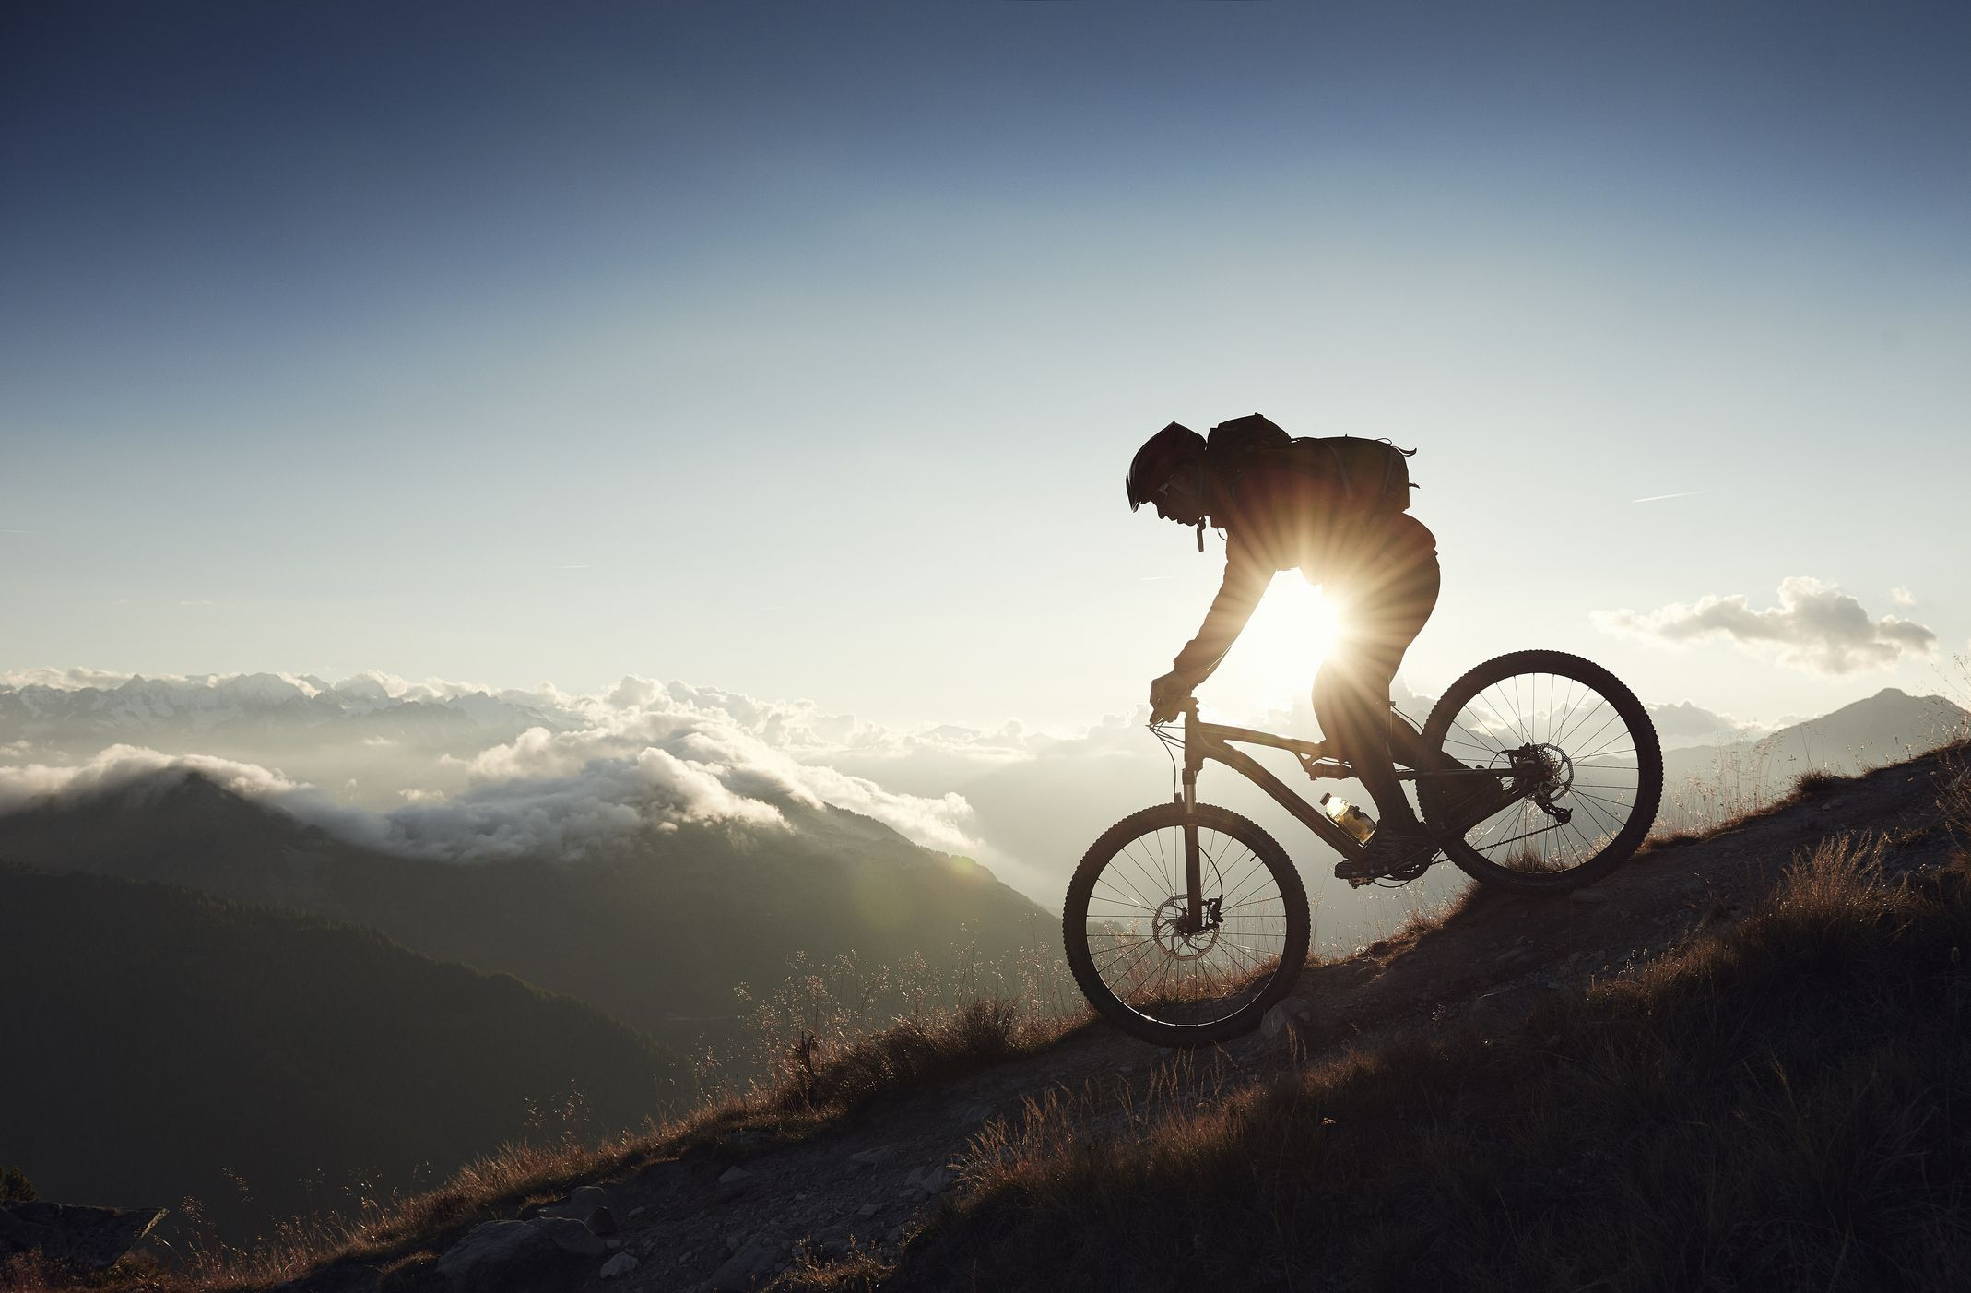

<https://www.popularmechanics.com/adventure/outdoor-gear/g3104/best-mountain-bikes/>

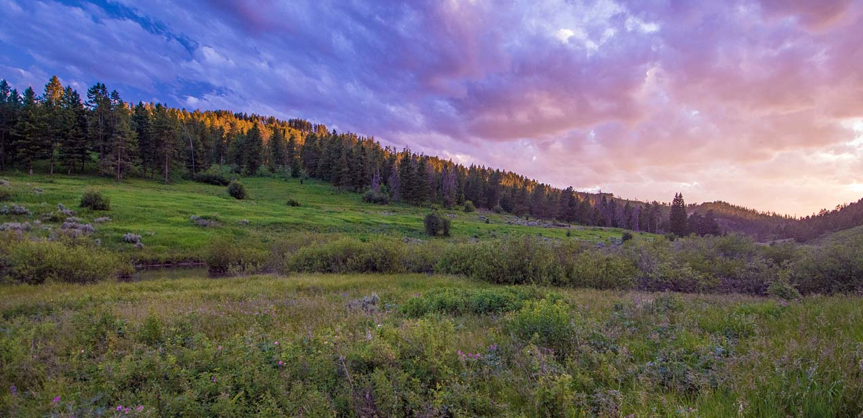

<http://www.skmontana.com/>

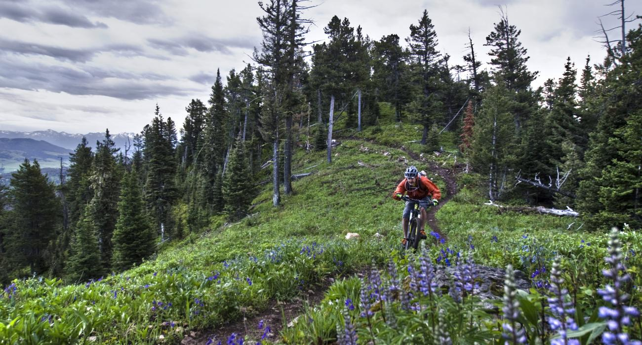

<https://www.visittheusa.com/destination/bozeman>

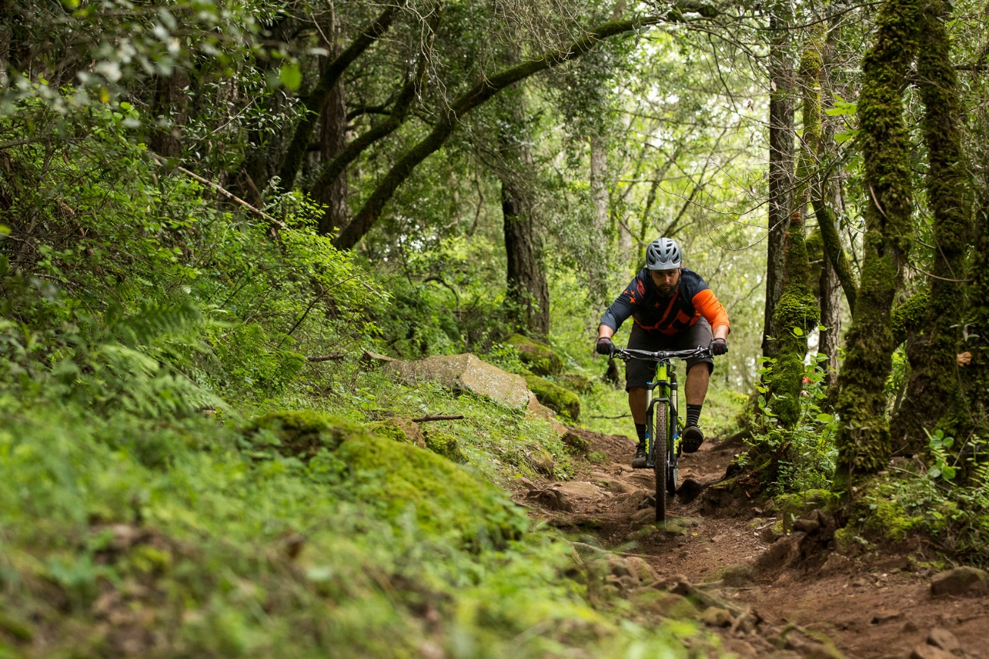

<https://www.vitalmtb.com/features/First-Look-First-Ride-Norco-Optic,1353>

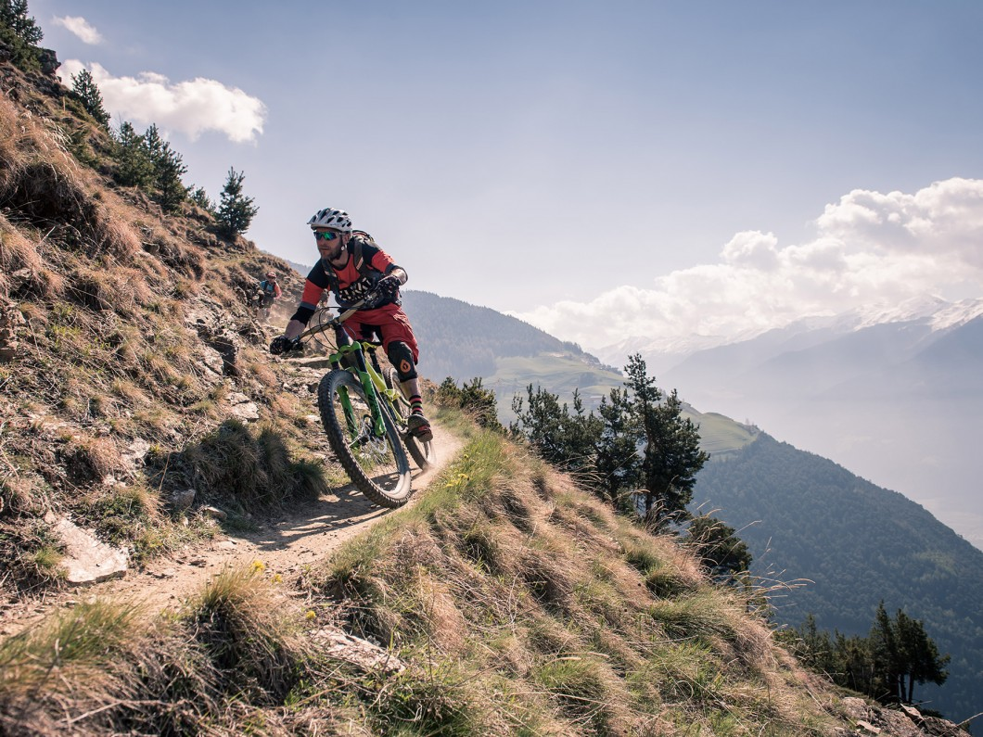

<http://chaletsportsmt.com/mountain-biking/>

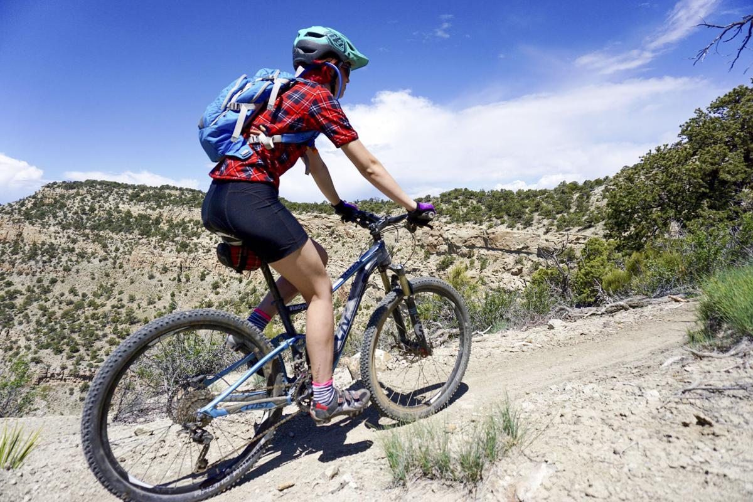

<https://www.bozemandailychronicle.com/outdoors/mountain-bikers-dream-of-copper-city-trails-coming-true/article_78cf8317-4818-57dc-a418-3df0177f7c9b.html>

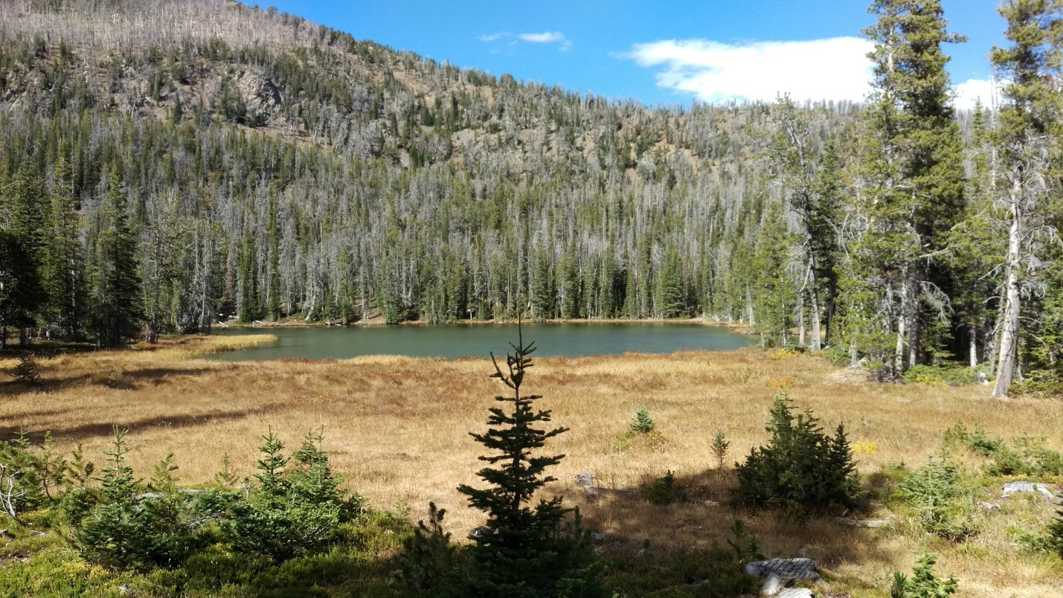

<https://traderiskguaranty.com/trgpeak/5-amazing-mountain-biking-trails-near-bozeman/>

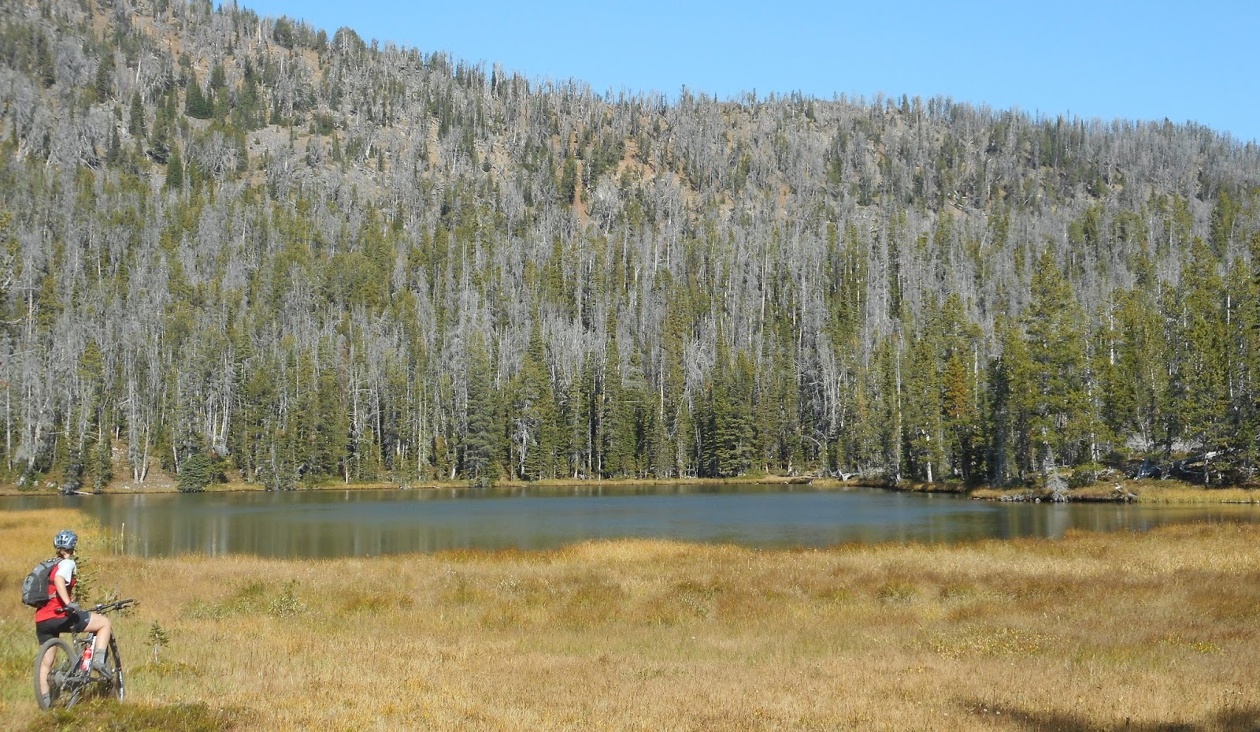

<http://mathgeekadventures.blogspot.com/2015/09/>

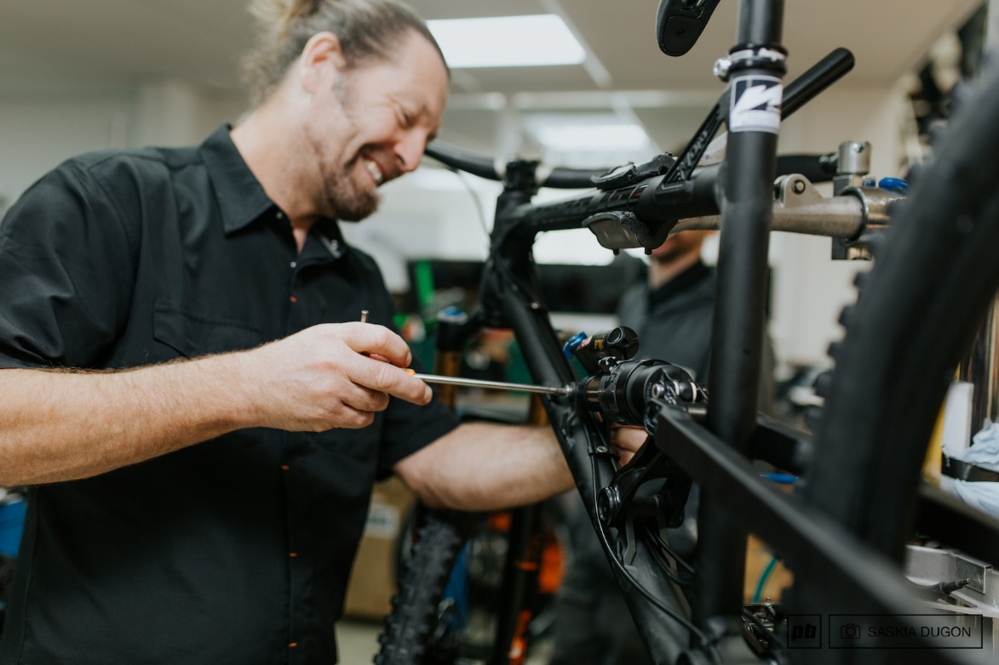

<https://www.pinkbike.com/news/the-interview-chris-porter-2017.html>

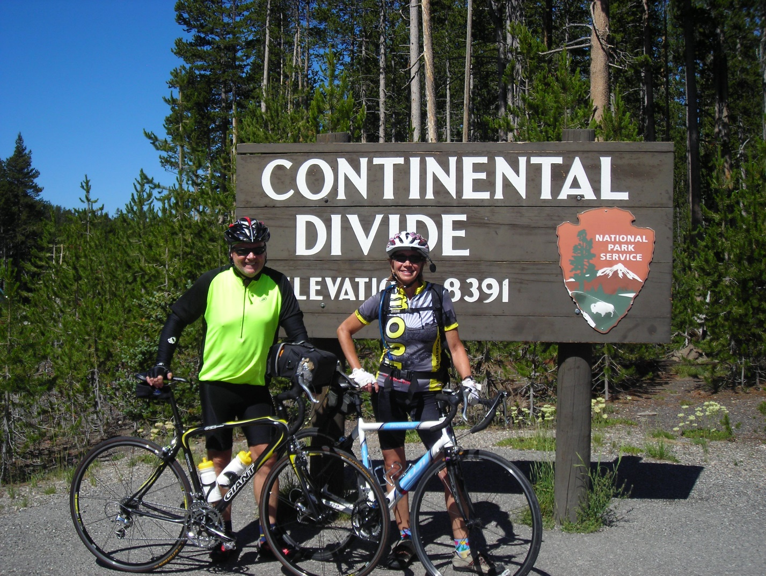

<https://mfacrossamerica.wordpress.com/category/ride-by-state/wyoming/page/2/>